3. Git-HOL :
P4Merge Setup Commands
- git config --global diff.tool p4merge
Configures Git to use P4Merge as the default visual diff tool.
- git config --global difftool.p4merge.path "C:/Program Files/Perforce/p4merge.exe"
Sets the executable path for P4Merge on Windows.
Branching Commands
- git branch GitNewBranch
Creates a new local branch named GitNewBranch.
- git branch -a
Lists all local and remote branches in the repository, showing an asterisk (*) next to the current active branch.
- git checkout GitNewBranch
Switches from the current branch to GitNewBranch.
- echo "Feature updates in new branch" > feature.txt
Creates a new file named feature.txt containing text content inside the working directory.
- git add feature.txt
Stages feature.txt for the next commit.
- git commit -m "Add feature.txt in GitNewBranch"
Saves the staged changes to the local branch history with a descriptive message.
- git status
Displays the working tree status to verify if there are any unstaged or untracked changes.
Merging & Visual Diff Commands
- git checkout main (or git checkout master)
Switches back to the target/trunk branch (main or master).
- git diff main..GitNewBranch
Lists line-by-line differences between main and GitNewBranch directly in the command line interface.
- git difftool main..GitNewBranch
Launches P4Merge to display side-by-side visual differences between main and GitNewBranch.
- git merge GitNewBranch
Merges the changes from GitNewBranch into the currently active branch (main).
- git log --oneline --graph --decorate
Displays a compact, single-line commit history graph showing branch structure, merges, and head pointers.
- git branch -d GitNewBranch
Safely deletes GitNewBranch after its changes have been merged into main.
☁️ Remote Synchronization
- git push origin main
Pushes the merged commit history on main to the remote repository (GitHub/GitLab).

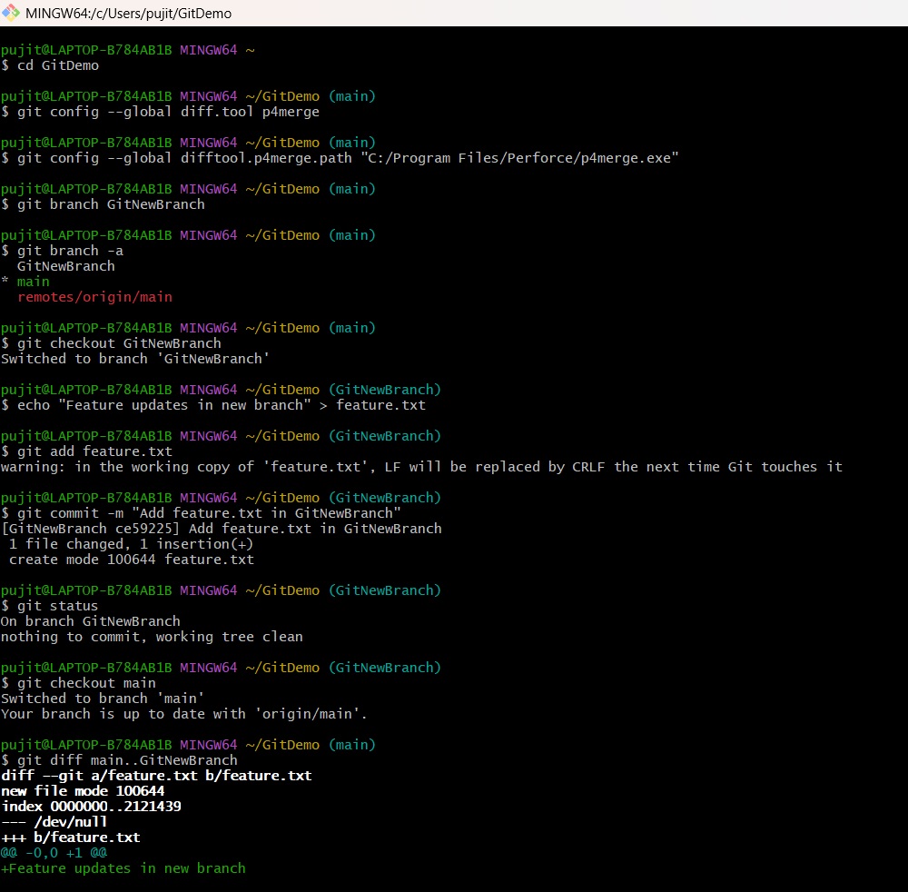

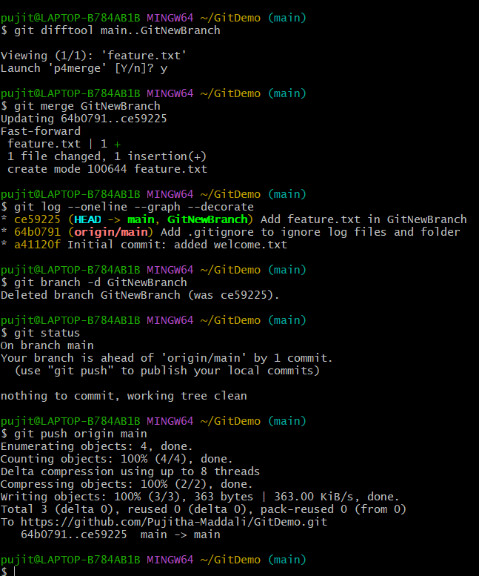

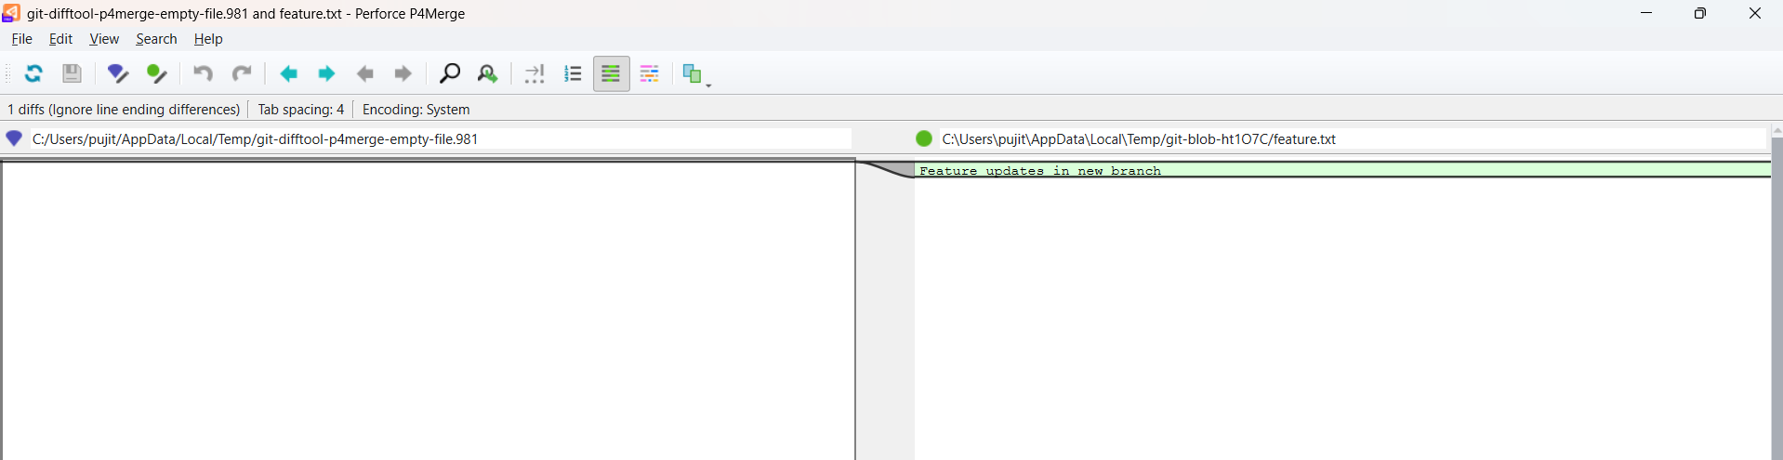

Feature.txt commited into GitHub:
